Daniel Fryer
Assignment 9.2 API
2/28/2026
Step 4 results:

Step 5 results:
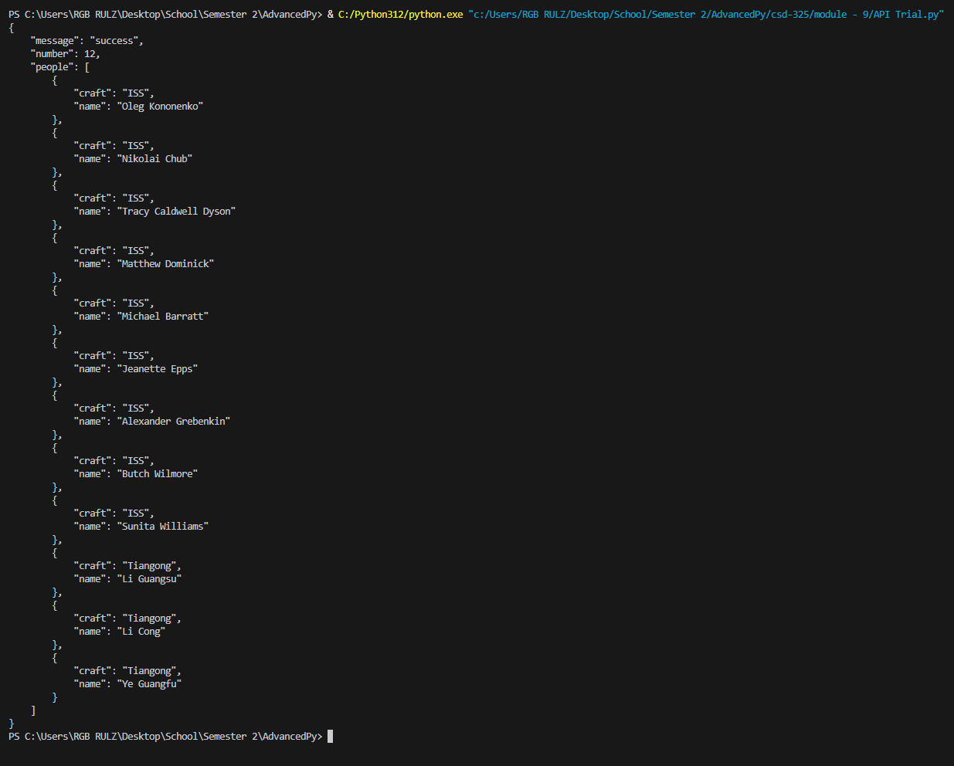

Step 6 Results:
A: using the D&D API
B:
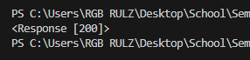
C:
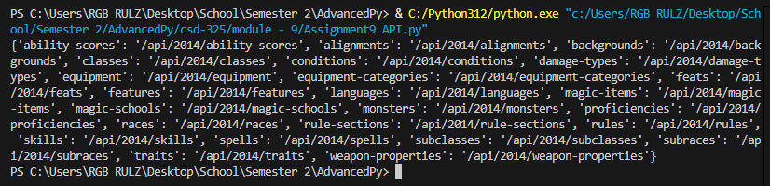
D/E:
